# Design Document:

Spirits of Jinmenju

Nathan Morrison

## Summary

Spirits of Jinmenju is a first person and third person rpg visual novel style game, similar to a mix of Undertale or Danganronpa, with an emphasis on dialogue options and world building. The player will explore a university that consists of multiple characters with different personalities, while navigating dialogue sections, keeping spirit levels from dropping, and unlocking puzzles to the secret of Jimnenju. This will serve as a short one chapter long beta of a game project I want to create outside of university.

## Gameplay

### Gameplay Loop

The basic gameplay loop of Spirits of Jinmenju can be broken down into three parts: puzzles, dialogue, investigation. The player will first explore the world with the company of characters in the game. From there, they will have to pay attention to the dialogue to help influence their choices later. As the game progresses, the other characters in the game will cause conflict which the player will have to break up using their knowledge of past dialogues and using their spirit level.

### Major Mechanics

Spirits of Jinmenju can be characterized by the following major mechanics.

1. A decision tree style code based on the decisions made in dialogue
2. An HP mechanic called “spirit” that will increase or decrease on decisions.
3. A way of recalling past conversations to help with decision making.

## Art and Visuals

I will be drawing from two games in developing the artstyle and mechanics.

The first is the visual novel and investigation game *Phoenix Wright: Ace Attorney.* This game features visual novel mechanics and also the mechanic of pointing out weakness in the opposition’s dialogue/actions.

*Phoenix Wright: Ace Attorney (2001)*

The second game is the Danganronpa series. This game series, much like Phoenix Wright, deals with pointing out weaknesses in dialogue passed on past interactions. Spirits of Jinmenju will consist of a similar minimalistic anime-like art style.

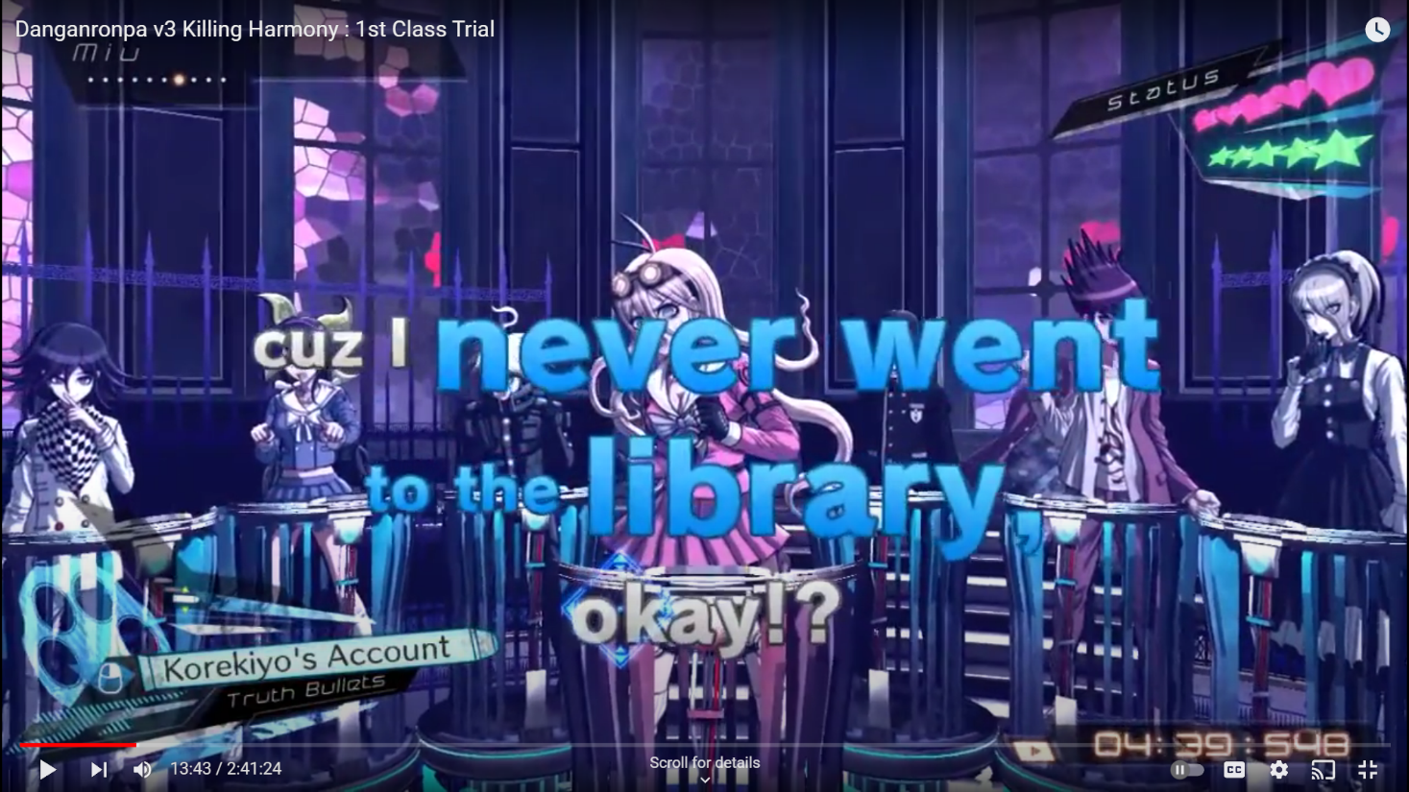

*Danganronpa V3: Killing Harmony (2017)*

Here is a mockup. I am obviously not an artist so it is a quick 5 minute MS Paint idea sketch.

## Development Plan

Here I provide an outline of my development goals for the next 6 weeks. My goal is to get the basic character down with a small example level showing how they can explore.

**Week 1:** Completing writing the story, sketching character creation.

**Week 2:** Creating world tiles to create the scenes and world the player will be in.

**Week 3:** Developing a basic dialogue system with a decision tree mechanic.

**Week 4:** Creating a puzzle or puzzles for the player to complete

**Week 5:** Working on finer details such as sound effects, music., and refining dialogue and mechanics.

**Week 6:** Play testing and minor tweaks

I am confident that after reaching this stage, I will be able to complete my submission in the following four weeks.